# 

# 

# **Network Infrastructure**

# **Proposal**

Networking Appendix

1. **Network Infrastructure…………………………………………………………………………27**
   1. Original/Proposed Network Information Summary pg. 29
   2. Original Network Infrastructure pg.30
   3. Proposed Network Infrastructure pg. 32
   4. Proposed Backup Network Infrastructure pg.43
2. **Original/Proposed Equipment, Software………………………………………………………35**
   1. Original Equipment pg 35
   2. Proposed Equipment pg. 36
   3. Patches, Equipment, Software pg. 38
3. **Domain Specifications…………………………………………………………………………...42**
   1. Network Blueprint pg 43
   2. Naming Standards pg. 44
   3. IP Addressing and Subnetting pg. 46
   4. National Footprint pg. 52
   5. Domain Topology pg. 52,53
4. **Ever Health Security Plan/Information………………………………………………………56**
   1. Ever Health Disaster Recovery Plan pg. 57
   2. Network Security Information pg. 58

Proposed/

Original Network Infrastructure

**Original/Proposed Network Information Summary**

Our old install was very simple and less expandable and could therefore not be implemented in order to answer today`s enterprise needs. This old infrastructure was made of basic LAN, with a decentralized administration type of install. The old infrastructure was an intranet they had no reason to connect to the internet, but now that they have a website and have need to have better backups for customer information we have moved from this design. The old infrastructure had archaic equipment such as hubs and bridges. Which cause network congestion because hubs only support 100 MHz max bandwidth, were half duplex, and broadcast domains.

Our updated and proposed version will allow for a much up to dated version with a centralized administration. We will revamp the installation and will allow ever health domain to be centrally managed. This location will contain the Forest Root Domain Controller. We intend to install DC in all 15 current locations. This location will therefore become Directory Sites. Doing so will allow everhealth.com admins to apply permissions and restrictions according to the ever health gym standards. We offering a proposal made of a hybrid type of network, in which, the HQ and all different sites or locations will be able to share information with one another, while allowing information replication, authentication, and authorization. With the new network we added switches which greatly improve the network through full duplex and vlans. We have also introduced domain controllers and have enhanced security.

EVER HEALTH ORIGINAL HQ LOCATION SCHEMA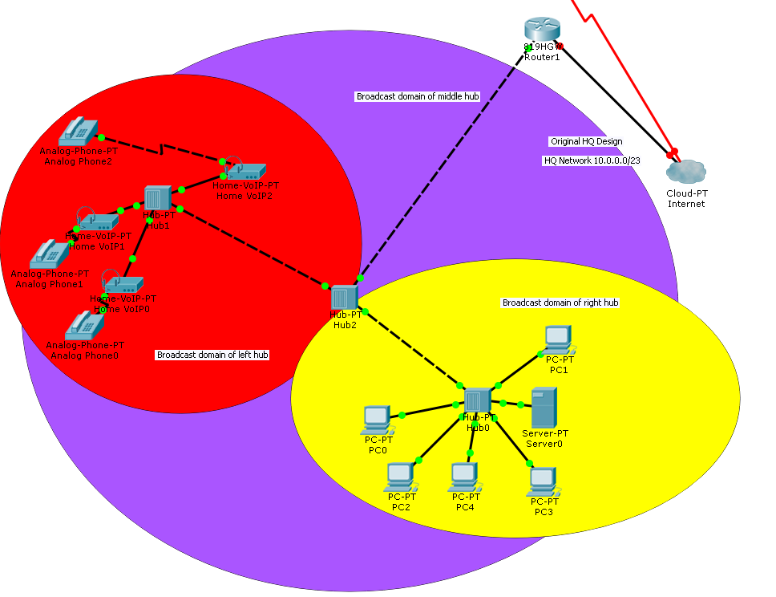



ORIGINAL EVER HEALTH GYM SITE DESIGN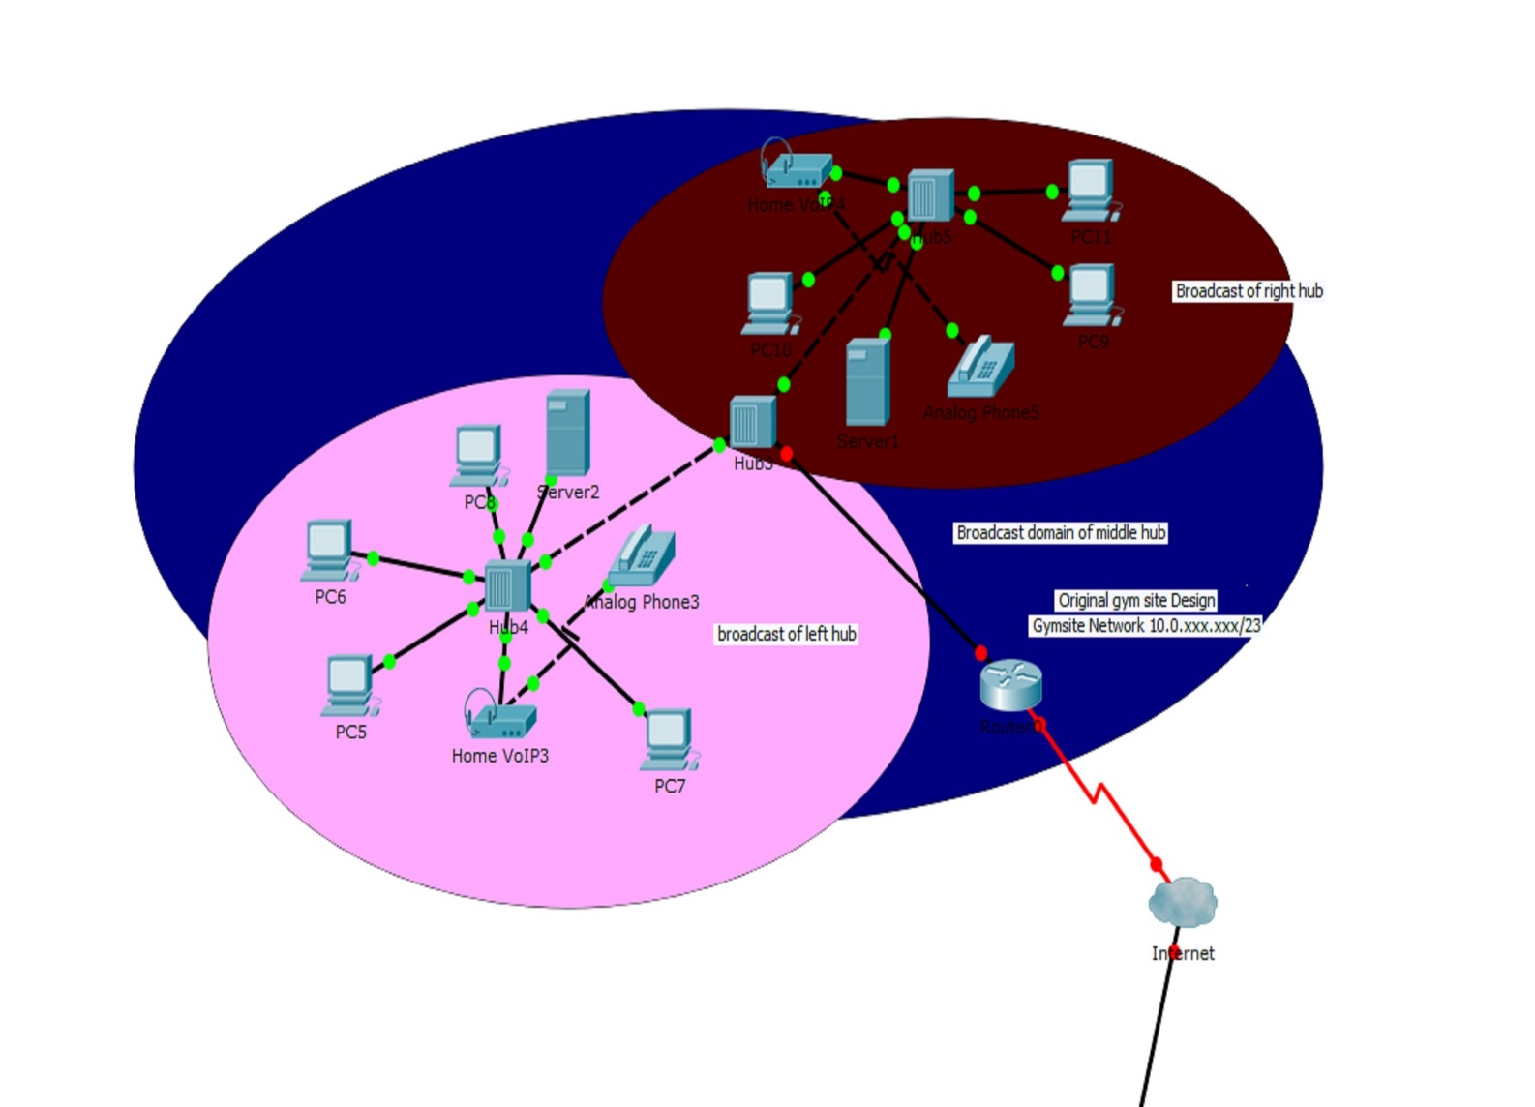

# EVER HEALTH PROPOSED GYM HQ REDESIGNEDproposed network

PROPOSED EVER HEALTH GYM SITE REDESIGNED NETWORKS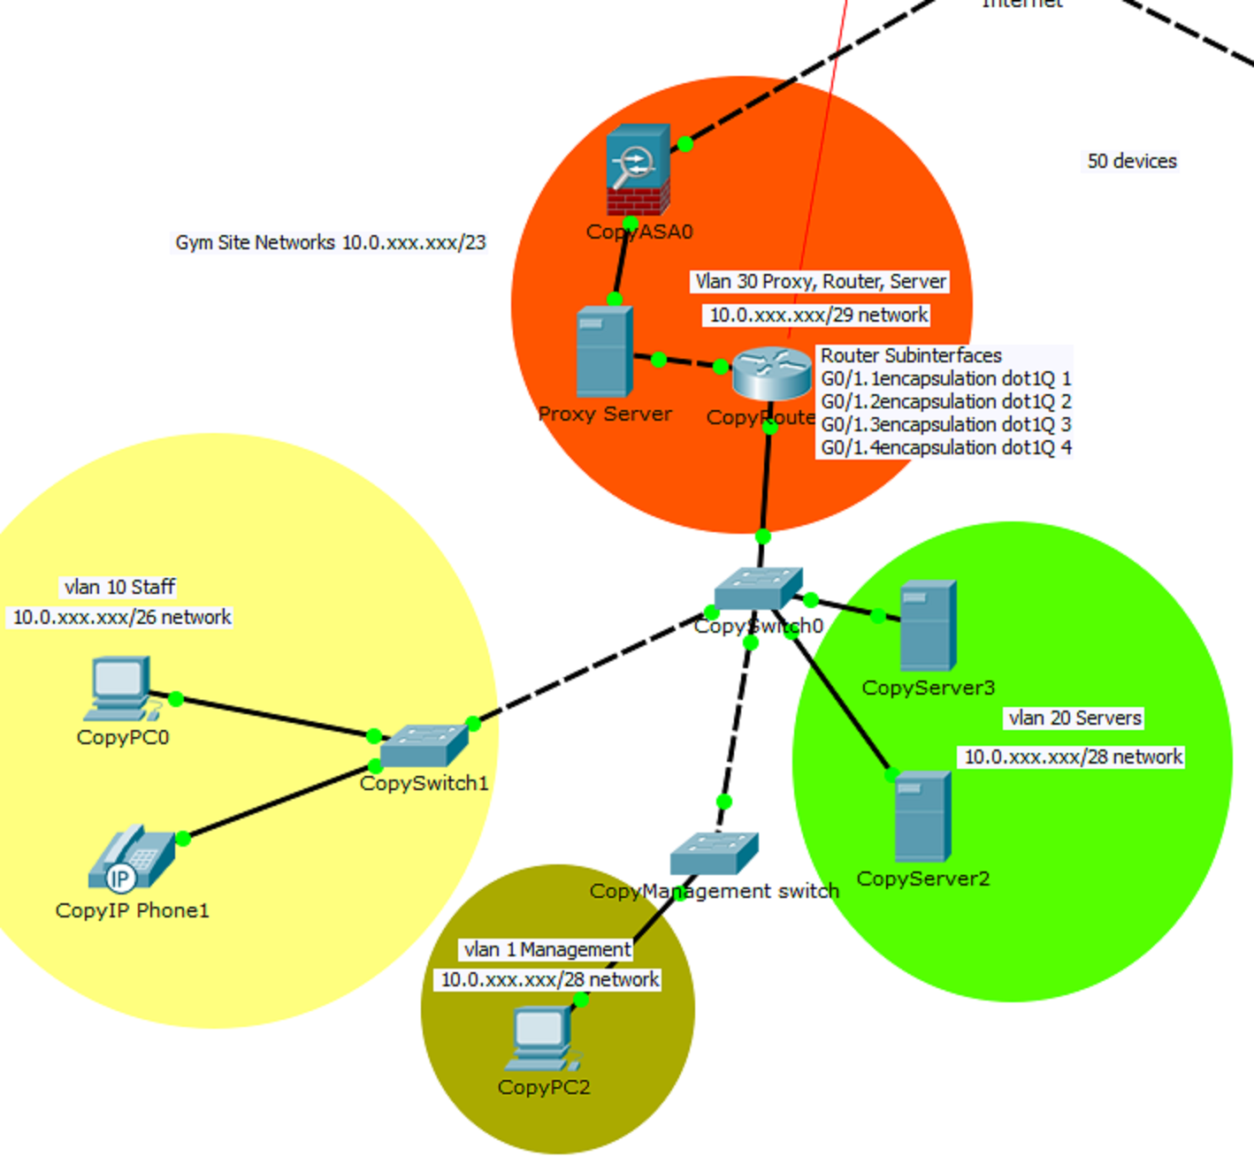

PROPOSED BACKUP SERVER NETWORK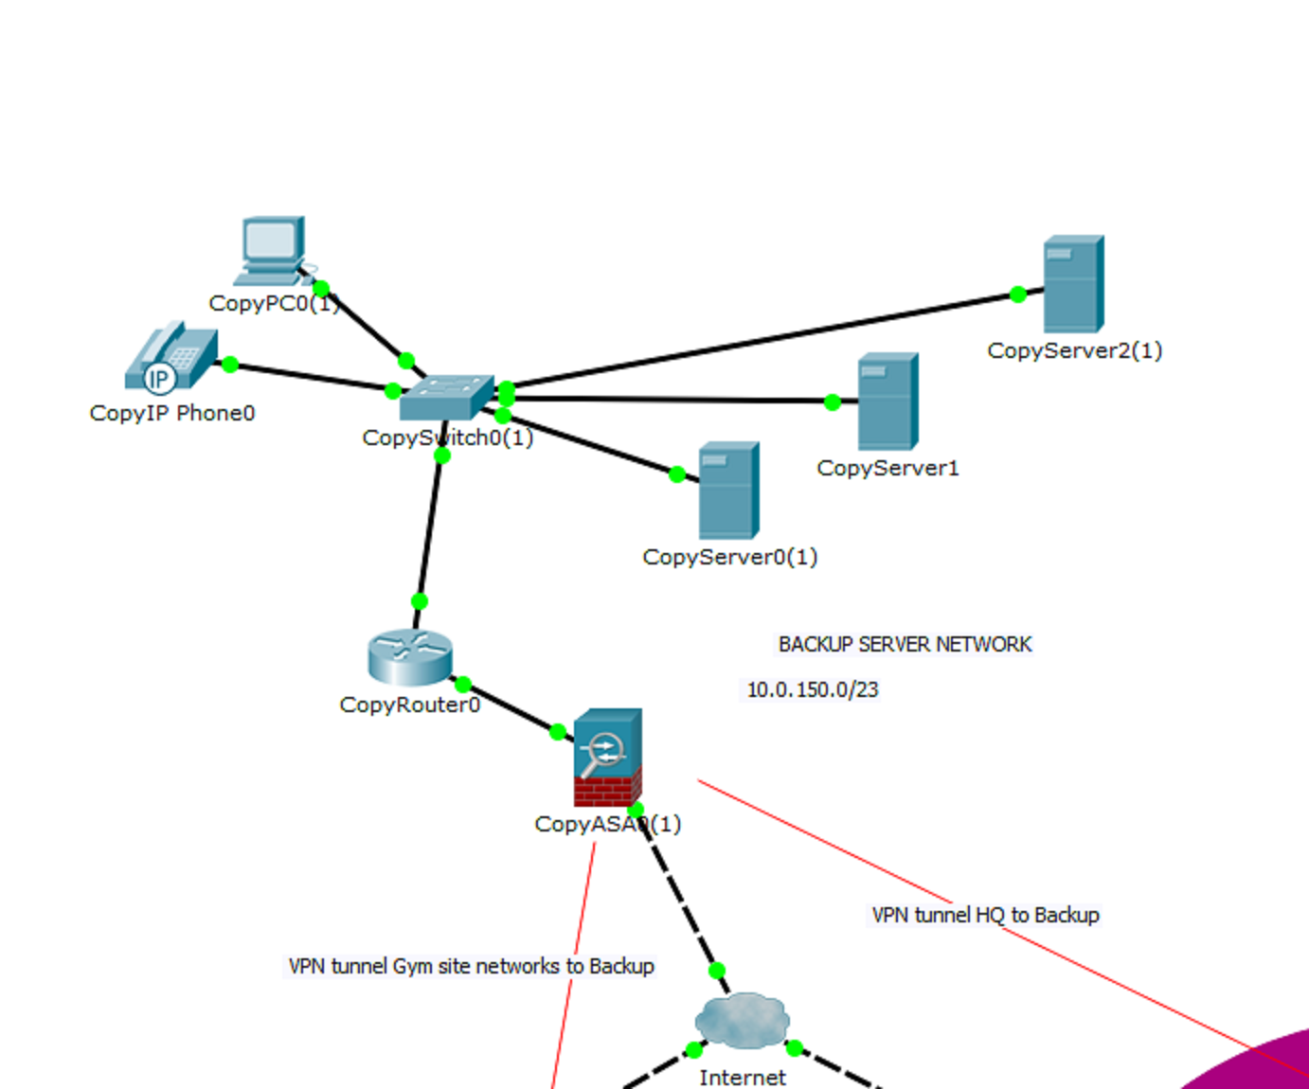



# Original/

Proposed Equipment and Software

ORIGINAL EQUIPMENT DOCUMENT

**The original HQ had 50 pcs**

12 hubs

1 router

10 printers

20 VoIP devices

Analog 20 phones

6 servers

**The gym site networks**

1 router per site

9 hubs per site

20 personal computers per site

5 printers per site

10 VoIP Devices per site

10 Analog phones per site

3 servers per site

### PROPOSED EQUIPMENT/SOFTWARE SERVICES DOCUMENT

### Bulk Cat5e Red Ethernet Cable, Solid, UTP (Unshielded Twisted Pair), Pullbox, 1000 foot $70.07 per box which is used outside walls. We used 4 boxes so $280.28 in all.

#### For all site we use Bulk Shielded cat5e gray Ethernet cable, solid, pullbox 1000 foot for inside the walls $136.21 per box which we used 8 which is 1089.68 in all.

#### HQ has 14 Cisco Catalyst WS-C2960S-24TS-L Switch 24 Ports Managed Rack Mountable each switch is $850.00 so $11900.00 in all.

#### HQ has 1 Cisco 1941 Integrated wired router, Cisco1941/k9 they are $471.94 including WIC-2T WAN Interface Card.

## HQ has 200 10 Zig Technology - V1200-P - 10ZiG V1200-P Zero Client - Teradici - 512 MB RAM - DVI - 4 Total USB Port(s) they are 317.95 per which is $63590.00

### HQ has 30 Cisco 8861 Gigabit IP Phone - CP-8861-K9 which are $265.00 each. Which are $7950.00 in all.

# HQ has 20 HP® LaserJet Enterprise M604N Single-Function Mono Laser Printer

In all which are $594.99 each. Which is 11899.80 in all.

Fortinet FortiGate-900D / FG-900D NGFW UTM Firewall Security Appliance which we need 1 for HQ costs 14,000

6 servers all costing around $4000 per which is 24000 in all

In all the HQ equipment upgrades costs are 135181.7

Each gym site has 4 switches which there are 14 sites so 56 switches in all. So it will cost $47600.00.

Each gym site has 1 router which there are 14 sites so 14 routers in all. It will cost $6607.16 in all.

Each gym site has 10 thin net which there are 14 sites so 140 zero clients in all. Which will cost $44513.00 in all

### Each gym site has 10 Cisco 8861 Gigabit IP Phone - CP-8861-K9 which are 140 in all. Which is $37100.00 in all.

# Each gym site has 5 HP® LaserJet Enterprise M604N Single-Function Mono Laser Printer

and there is 14 sites which is 70 in all they are $594.99 each. Which is $41649.30 in all

#### For all site we use Bulk Shielded cat5e gray Ethernet cable, solid, pullbox 1000 foot for inside the walls $136.21 per box which we used 84 boxes which is $11441.64 in all.

### Bulk Cat5e Red Ethernet Cable, Solid, UTP (Unshielded Twisted Pair), Pullbox, 1000 foot $70.07 per box which is used outside walls. We used 56 boxes which is $3923.92 in all

Fortinet FortiGate-90D / FG-90D Next Generation (NGFW) Firewall UTM Appliance (Hardware Only) for 14 sites at $758.00 per which is $10612 in all.

Each gym site has 3 per which there are 14 sites in all which is 42 servers at 4000 apiece. Which in all 168000

The Backup Site has

3 Servers 4000 per which is $12000.00 in all

1 Cisco 8861 Gigabit IP Phone - CP-8861-K9 $265.00

1 Bulk Shielded cat5e gray Ethernet cable $136.21

1 Bulk Cat5e Red Ethernet Cable, Solid, UTP $70.07

1 10ZiG V1200-P Zero Client $317.95

1 Fortinet FortiGate-90D $758.00

1 Cisco 1941 Integrated wired router, Cisco1941/k9 they are $471.94

1 Cisco Catalyst WS-C2960S-24TS-L Switch 24 Ports Managed Rack Mountable each switch is $850.00

Which is $14869.17

The total cost of the remote gym locations equipment upgrades are 521480.84

## Software Packages

## Symantec Endpoint Protection 12.1 - 25 User 499.99

340 Zero clients which is going to cost $6,999.86 in all for 14 licenses/ we also have 10 free licenses that are unused.

## PRTG Network Monitor

Zero clients give customers an even higher level of security because nothing is stored on the device itself, and the brains of the device is simpler and easier to protect. Whereas traditional PCs maintain surfaces where threats can take hold – for example operating systems, CPU or memory – zero clients don’t include common target operating systems like Linux or Windows, making the endpoint virtually impenetrable to device or network-borne attacks.

This is what is meant by the term zero attack surface – there is nothing for malware to attack. Valuable data is instead securely stored in the datacenter and is streamlined to users through encrypted protocols.

We are looking at around $529480.70 including security software and hardware only. Labor prices and hosting prices aren’t included in this outlook.

Hosting through Microsoft Azure and Rackspace is going to be around $40,000.

So, I was thinking about offsite virtualization or at least hybrid we could go through companies like Microsoft Azure or Rackspace which would mean that they wouldn’t have to hire staff for management/repair of equipment and they could dodge equipment/hardware costs. We could also do Carbonite which does Hyper-V and backs up data.

In all the costs altogether is $569480.70



|  |  |  |  |  |
| --- | --- | --- | --- | --- |
| Exchange 2103 Pre-requisites Step | Update | Action | Outcome | URL |
| 1 | .Net Framework 4.5.2  Standalone Version | Install | Success | <http://www.microsoft.com/en-us/download/confirmation.aspx?id=42642> |
| 2 | Windows Management 3.0 | Install |  | <http://www.microsoft.com/en-us/download/confirmation.aspx?id=34595> |
| 3 | Unified Communications Managed API 4.0 Runtime | Install | Success | <http://www.microsoft.com/en-us/download/confirmation.aspx?id=34992> |
| 4 | KB974055 | Install | Success | <http://www.microsoft.com/en-us/download/details.aspx?id=17331> |
| 5 | Hotfix KB2619234 | Install | Success | **Below |
| 6 | Hotfix Insecure library KB2533623 | Install | Success | <https://support.microsoft.com/en-us/kb/2533623> |

*<http://hotfixv4.microsoft.com/Windows%207/Windows%20Server2008%20R2%20SP1/sp2/Fix381274/7600/free/437879_intl_x64_zip.exe> (Hotfix)

**NETWORK INFRASTRUCTURE OF EVER HEALTH**

## **Server Requirements**

|  |  |  |  |  |  |
| --- | --- | --- | --- | --- | --- |
| Server Requirements | | | | | |
| Type | **Quantity** | **Bit Size / Processor** | **RAM** | **Memory** | **Additional** |
| Microsoft Exchange 2013 | **2** | **64 Bit CPU / 1.4 GHz** | **8 GB Minimum** | **30 GB on Install Drive** |  |
| Windows Server 2008 R2 | **2** | **64 Bit CPU / 1.4 GHz** | **4 GB** | **40 GB** |  |
| Windows Lync Server 2013 – Front-End | **1** | **64 Bit CPU / 2.26 GHz** | **32 GB** | **72 GB x 8** |  |
| Windows Lync Server 2013 – Back-End | **1** | **64 Bit CPU / 2.26 GHz** | **32 GB** | **72 GB x 8** |  |
| Windows Lync Server 2013 – Edge Transport Server | **1** | **64 Bit CPU / 2.0 GHz** | **16 GB** | **72 GB x 4** | **\* 1 Gbps NIC Card** |

## 

## Pricing

|  |  |  |
| --- | --- | --- |
| Service Type | Associated Expense | Total |
| Windows Server 2008 | $3,999 x 2 | $7,998 / Year |
| Exchange / Office 365 Education | Free | Free |
| Exchange / Office 365 Enterprise E1 | $8 Per Employee x 400 (Per Month) | $3,200 / Month - $38,400 / Year |
| Lync Server 2013 | 3,646 (Per Front End Server) x 2 | $7,292 ($1,823 / Month) |
| Lync Server 2013 Basic (Client Side) | Free | Free |

# 

# Domain

Specifications

# **NETWORK BLUEPRINT FOR THE EVER HEALTH GYM**

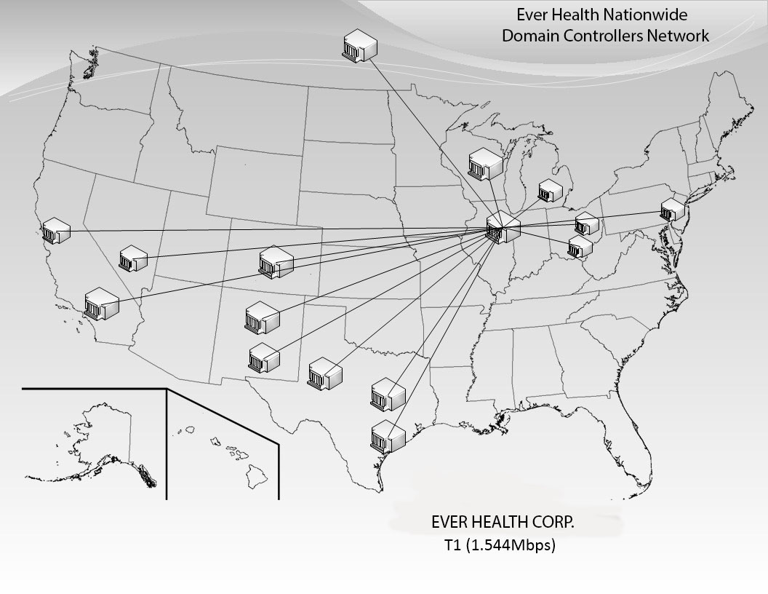

**This section will detail the naming standards for Active Directory objects. These standards will be used during the creation of the everhealth.com Domain to maintain a consistent and reliable naming scheme. Maintaining these standards will allow everhealth.com administrators an organized environment.**

# 

# Everhealth.com Domain Specifications

• Naming Standards.

• IP Addressing & Network Sub-Netting.

• National Footprint.

• Ever Health Domain specification

Naming Standards

### Single Domain Server Naming Standards

|  |  |  |
| --- | --- | --- |
| Object | Standard | Example |
| Windows Server | TYPE-SITE-DC# | WS-ARL-DC1 |
| Exchange Server | TYPE-SITE-# | EXC-ARL-1 |
| * Additional Server Objects Added To Sites | TYPE-SITE-#  (Number incremented by adding incrementing Alphabetical notation. With “A” indicating the first addition server object.) | EXC-ARL-1A |

Single Domain User Naming Standards

|  |  |  |
| --- | --- | --- |
| Name | Standard | Example |
| John Smith | First Initial & Last Name & Domain | jsmith@everhealth.com |
| * Additional User Objects Composed of Identical Names | *First Initial & Last Name01  Incremented & Domain | Jsmith01@everhealth.com |

Single Domain Computer Naming Standards

|  |  |  |
| --- | --- | --- |
| Object | Standard | Example |
| Employee Computer | SITE-TYPE-DEPARTMENT-INCREMENTING NUMBER | COL-WS-CUS-01 | |
| Empl Computer | SITE-TYPE-LOCATION-INCREMENTING NUMBER | COL-SS-CUS-01 | |
| Site Legend | | | |
| Computer Object | Defined by the corporate Standard for Sites. | Columbus = COL | |
| Type Legend | | | |
| Work Station | Any host computer owned and operated by users with Employee Status. | WS | |
| Customer Service | Any host computer owned by everhealth.com and operated by employer with Customer Service Status. | CS | |
| Public Station | Any host owned by everhealth.com and operated by users with Guest Status. | PS | |
| User Type Legend | | | |
| Employee | Defined as NON-Administrative everhealth.com | EMP | |
| Customer | Defined as user object with enrolled status. | GUE | |

Computer Name = WS-CHI-DC1

Admin Password – P@ssw0rd

NetBIOS Computer Name = WS-CHI-DC1

IP Address = 10.4.0.1

DNS = 10.4.0.1

Subnet Mask = 255.248.0.0

NetBIOS Computer Name = WS-CHI-DC2

IP Address = 10.6.0.1

DNS = 10.4.0.1

Subnet Mask = 155.248.0.0

# IP Addressing and Network Subnetting

### For the 10.0.0.0 network with the subnet mask 255.255.254.0

|  |  |  |  |  |
| --- | --- | --- | --- | --- |
| **Locations** | **Network ID** | **From** | **To** | **Broadcast ID** |
| **Columbus** | **10.0.0.0** | **10.0.0.1** | **10.0.1.254** | **10.0.1.255** |
| **Reserved** | **10.0.2.0** | **10.0.2.1** | **10.0.3.254** | **10.0.3.255** |
| **Reserved** | **10.0.4.0** | **10.0.4.1** | **10.0.5.254** | **10.0.5.255** |
| **Reserved** | **10.0.6.0** | **10.0.6.1** | **10.0.7.254** | **10.0.7.255** |
| **Reserved** | **10.0.8.0** | **10.0.8.1** | **10.0.9.254** | **10.0.9.255** |
| **Chicago** | **10.0.10.0** | **10.0.10.1** | **10.0.11.254** | **10.0.11.255** |
| **Reserved** | **10.0.12.0** | **10.0.12.1** | **10.0.13.254** | **10.0.13.255** |
| **Reserved** | **10.0.14.0** | **10.0.14.1** | **10.0.15.254** | **10.0.15.255** |
| **Reserved** | **10.0.16.0** | **10.0.16.1** | **10.0.17.254** | **10.0.17.255** |
| **Reserved** | **10.0.18.0** | **10.0.18.1** | **10.0.19.254** | **10.0.19.255** |
| **Cincinnati** | **10.0.20.0** | **10.0.20.1** | **10.0.21.254** | **10.0.21.255** |
| **Reserved** | **10.0.22.0** | **10.0.22.1** | **10.0.23.254** | **10.0.23.255** |
| **Reserved** | **10.0.24.0** | **10.0.24.1** | **10.0.25.254** | **10.0.25.255** |
| **Reserved** | **10.0.26.0** | **10.0.26.1** | **10.0.27.254** | **10.0.27.255** |
| **Reserved** | **10.0.28.0** | **10.0.28.1** | **10.0.29.254** | **10.0.29.255** |
| **Detroit** | **10.0.30.0** | **10.0.30.1** | **10.0.31.254** | **10.0.31.255** |
| **Reserved** | **10.0.32.0** | **10.0.32.1** | **10.0.33.254** | **10.0.33.255** |
| **Reserved** | **10.0.34.0** | **10.0.34.1** | **10.0.35.254** | **10.0.35.255** |
| **Reserved** | **10.0.36.0** | **10.0.36.1** | **10.0.37.254** | **10.0.37.255** |
| **Reserved** | **10.0.38.0** | **10.0.38.1** | **10.0.39.254** | **10.0.39.255** |
| **Milwaukee** | **10.0.40.0** | **10.0.40.1** | **10.0.41.254** | **10.0.41.255** |
|  | **10.0.42.0** | **10.0.42.1** | **10.0.43.254** | **10.0.43.255** |
|  | **10.0.44.0** | **10.0.44.1** | **10.0.45.254** | **10.0.45.255** |
|  | **10.0.46.0** | **10.0.46.1** | **10.0.47.254** | **10.0.47.255** |
|  | **10.0.48.0** | **10.0.48.1** | **10.0.49.254** | **10.0.49.255** |
| **Dallas** | **10.0.50.0** | **10.0.50.1** | **10.0.51.254** | **10.0.51.255** |
|  | **10.0.52.0** | **10.0.52.1** | **10.0.53.254** | **10.0.53.255** |
|  | **10.0.54.0** | **10.0.54.1** | **10.0.55.254** | **10.0.55.255** |
|  | **10.0.56.0** | **10.0.56.1** | **10.0.57.254** | **10.0.57.255** |
|  | **10.0.58.0** | **10.0.58.1** | **10.0.59.254** | **10.0.59.255** |
| **Houston** | **10.0.60.0** | **10.0.60.1** | **10.0.61.254** | **10.0.61.255** |
|  | **10.0.62.0** | **10.0.62.1** | **10.0.63.254** | **10.0.63.255** |
|  | **10.0.64.0** | **10.0.64.1** | **10.0.65.254** | **10.0.65.255** |
|  | **10.0.66.0** | **10.0.66.1** | **10.0.67.254** | **10.0.67.255** |
|  | **10.0.68.0** | **10.0.68.1** | **10.0.69.254** | **10.0.69.255** |
| **Tucson** | **10.0.70.0** | **10.0.70.1** | **10.0.71.254** | **10.0.71.255** |
|  | **10.0.72.0** | **10.0.72.1** | **10.0.73.254** | **10.0.73.255** |
|  | **10.0.74.0** | **10.0.74.1** | **10.0.75.254** | **10.0.75.255** |
|  | **10.0.76.0** | **10.0.76.1** | **10.0.77.254** | **10.0.77.255** |
|  | **10.0.78.0** | **10.0.78.1** | **10.0.79.254** | **10.0.79.255** |
| **Albuquerque** | **10.0.80.0** | **10.0.80.1** | **10.0.81.254** | **10.0.81.255** |
|  | **10.0.82.0** | **10.0.82.1** | **10.0.83.254** | **10.0.83.255** |
|  | **10.0.84.0** | **10.0.84.1** | **10.0.85.254** | **10.0.85.255** |
|  | **10.0.86.0** | **10.0.86.1** | **10.0.87.254** | **10.0.87.255** |
|  | **10.0.88.0** | **10.0.88.1** | **10.0.89.254** | **10.0.89.255** |
| **Los Angeles** | **10.0.90.0** | **10.0.90.1** | **10.0.91.254** | **10.0.91.255** |
|  | **10.0.92.0** | **10.0.92.1** | **10.0.93.254** | **10.0.93.255** |
|  | **10.0.94.0** | **10.0.94.1** | **10.0.95.254** | **10.0.95.255** |
|  | **10.0.96.0** | **10.0.96.1** | **10.0.97.254** | **10.0.97.255** |
|  | **10.0.98.0** | **10.0.98.1** | **10.0.99.254** | **10.0.99.255** |
| **San Francisco** | **10.0.100.0** | **10.0.100.1** | **10.0.101.254** | **10.0.101.255** |
|  | **10.0.102.0** | **10.0.102.1** | **10.0.103.254** | **10.0.103.255** |
|  | **10.0.104.0** | **10.0.104.1** | **10.0.105.254** | **10.0.105.255** |
|  | **10.0.106.0** | **10.0.106.1** | **10.0.107.254** | **10.0.107.255** |
|  | **10.0.108.0** | **10.0.108.1** | **10.0.109.254** | **10.0.109.255** |
| **Denver** | **10.0.110.0** | **10.0.110.1** | **10.0.111.254** | **10.0.111.255** |
|  | **10.0.112.0** | **10.0.112.1** | **10.0.113.254** | **10.0.113.255** |
|  | **10.0.114.0** | **10.0.114.1** | **10.0.115.254** | **10.0.115.255** |
|  | **10.0.116.0** | **10.0.116.1** | **10.0.117.254** | **10.0.117.255** |
|  | **10.0.118.0** | **10.0.118.1** | **10.0.119.254** | **10.0.119.255** |
| **Las Vegas** | **10.0.120.0** | **10.0.120.1** | **10.0.121.254** | **10.0.121.255** |
|  | **10.0.122.0** | **10.0.122.1** | **10.0.123.254** | **10.0.123.255** |
|  | **10.0.124.0** | **10.0.124.1** | **10.0.125.254** | **10.0.125.255** |
|  | **10.0.126.0** | **10.0.126.1** | **10.0.127.254** | **10.0.127.255** |
|  | **10.0.128.0** | **10.0.128.1** | **10.0.129.254** | **10.0.129.255** |
| **Philadelphia** | **10.0.130.0** | **10.0.130.1** | **10.0.131.254** | **10.0.131.255** |
|  | **10.0.132.0** | **10.0.132.1** | **10.0.133.254** | **10.0.133.255** |
|  | **10.0.134.0** | **10.0.134.1** | **10.0.135.254** | **10.0.135.255** |
|  | **10.0.136.0** | **10.0.136.1** | **10.0.137.254** | **10.0.137.255** |
|  | **10.0.138.0** | **10.0.138.1** | **10.0.139.254** | **10.0.139.255** |
| **Arlington** | **10.0.140.0** | **10.0.140.1** | **10.0.141.254** | **10.0.141.255** |
|  | **10.0.142.0** | **10.0.142.1** | **10.0.143.254** | **10.0.143.255** |
|  | **10.0.144.0** | **10.0.144.1** | **10.0.145.254** | **10.0.145.255** |
|  | **10.0.146.0** | **10.0.146.1** | **10.0.147.254** | **10.0.147.255** |
|  | **10.0.148.0** | **10.0.148.1** | **10.0.149.254** | **10.0.149.255** |
|  |  |  |  |  |
| **Winnipeg** | **10.0.150.0** | **10.0.150.1** | **10.0.151.254** | **10.0.151.255** |
|  |  |  |  |  |
| Switches | +3 |  |  |  |
| Servers | +4 |  |  |  |
| Exchange Servers | +2 |  |  |  |
| Printers | +3 |  |  |  |
| Host Ranges | 1-2 | Exple:10.0.0.1 – 10.2.255.254 |  |  |

# Sample screenshot of IPV4 Setup

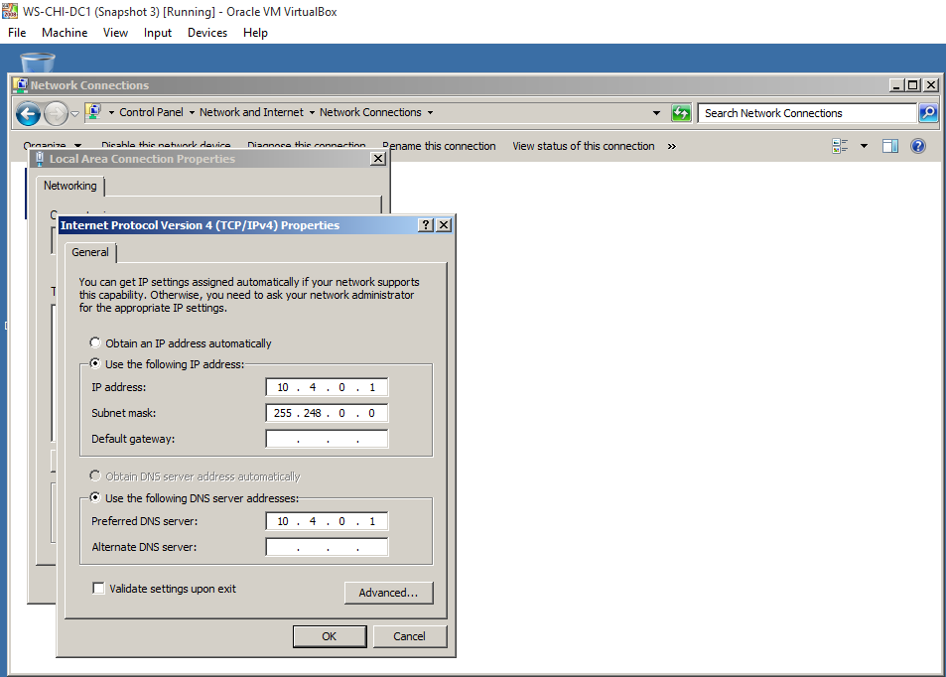

## National Footprint

Eagle Consulting has generated this state bird’s eye view of the everhealth.com Domain to better appreciate the scope of this network. Connecting lines represent the WAN Links that will provide overall connectivity to the everhealth.com Domain.

# Installing Ever Health Domain Controller

The primary location of the central management for ever health gym corp is located in Columbus, Ohio. This location will contain the Forest Root Domain Controller. We intend to install DC in all 15 current locations. This location will therefore become Directory Sites. Doing so will allow everhealth.com admins to apply permissions and restrictions according to the ever health gym standards.

Important areas of concern while lunching will be:

* Running dcpromo on Active Directory (AD)
* Choosing a deployment configuration
* Choosing the FQDN
* Adopting the Windows Server 2008 R2 or later
* Creating External OU Structure
* Creating Internal OU Structure
* Creating groups and passwords policies

The FQDN of the forest domain will be everhealth.com (Domain name= everhealth; Top Level Domain= .com)

**Important group settings and policies**

Groups will mainly be divided according to the management of the company structure. For instance, at the very top of the hierarchy, we could include **employees**, **customers**, and **vendors.**

Then the Employee group will be subdivided in **Administrators, regular staffs, administrative local, Executive, HR, etc…**

**GPS will be diverse and implemented in various aspect such as:**

* Software settings
* Windows settings
* Name resolution policies
* Security settings
* Local policies

**Policies on the other hands will include but will not limit to:**

* Configuring the Group Policy snap-in.
* Creating and managing Group Policy objects.
* Setting options for registry-based policy, scripts, and loopback policy.
* Using security groups with Group Policy.
* Linking multiple Group Policy Objects.
* Blocking and enforcing Group Policy.
* Maximum or minimum passwords age
* Maximum passwords length
* Password complexity requirements
* Password storage with reversible encryption
* Account policies
* .

## Ever Health Single Domain Topology C:\Users\murmu\AppData\Local\Microsoft\Windows\INetCacheContent.Word\Untitled finished.jpg

Ever Health corporate will install RWDC’s at all their Locations. These RWDC’s will offer the DNS Server Role and the Global Catalog Role.

Ever Health National Bird Eyes’ View

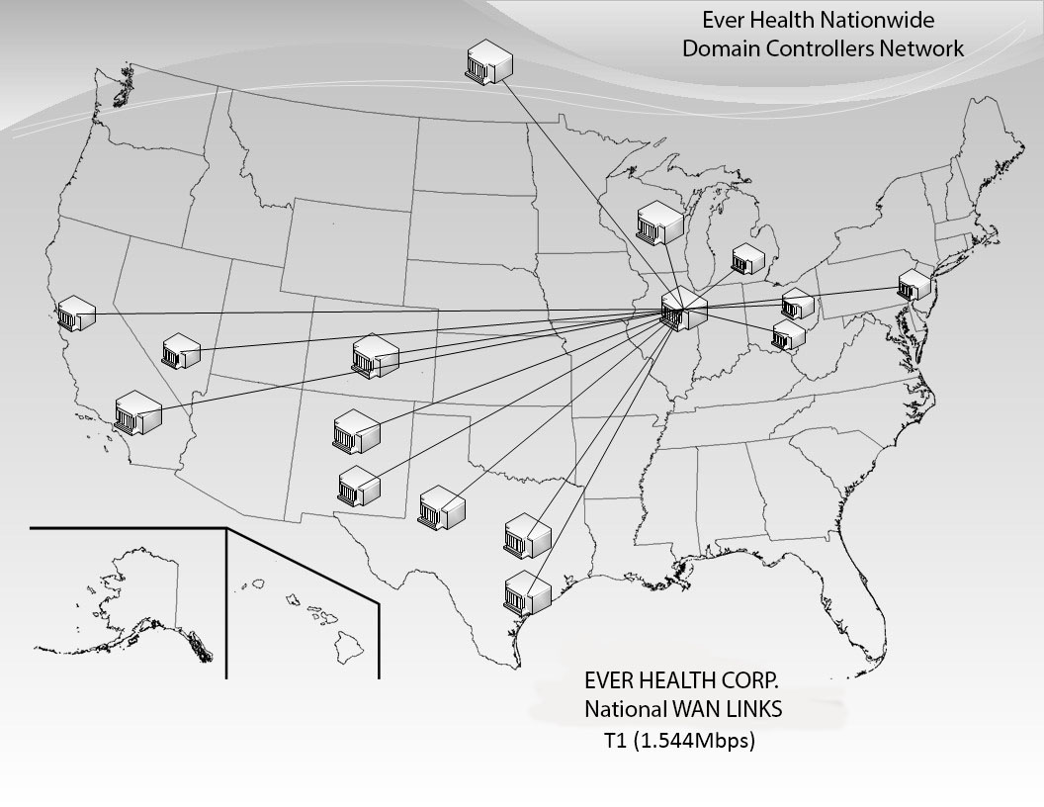

The Global Role will allow network resource authentication to occur locally.

Each Location will be assigned a Local Administrator. This designation will permit the Local Administrator Permissions to the facility RWDC.

*IP Addressing varies from standards because of Virtual Box environment.

IP Address = 10.28.0.1 -

DNS server = 10.28.0.1



Ever Health

Security

Plan/

Information

Network Security Information

We have a proxy server in place at the start of the network it is a gateway that hides the true network address of the computers connecting through it. A proxy server connects to the Internet, makes the requests for pages, connections to servers, etc., and receives the data on behalf of the computers behind it. The proxy server is also able to double up as a firewall it also has packet inspection.

We put a firewall in to stop destructive elements from entering the network. It will do this by using Stateful inspection. Which is the process of examining key parts of the packets and comparing it with a database of trusted information.

We have Norton on all the Zero-clients. Which also has a firewall/anti-virus. The zero-clients themselves are also very strong when it comes to security. They don’t have any hardware except a processor that runs certain protocols and no software at the client means that there is no vulnerability to malware. The virtualization itself is able to configure to reset itself every morning or whenever so even if the anti-virus doesn’t catch something the reset will.

We decided to go with a network monitoring software also known as PRTG. This software has tons of packages but the one that would be considered defensive is its Port mirroring ability. Where it makes a switch/router to send a copy of all the packets it’s seen through a certain port to you.

We will have the program SNORT running in intrusion detection mode, which the program will monitor network traffic and analyze it against a rule set defined by the user. The program will then perform a specific action based on what has been identified.

Physically we have the hardware servers/routers switches away in a locked/cooled room. We have a few cameras both inside and right outside of the room. If room is near exterior wall can add cement or steel bollards to stop people from ramming the wall and gaining entry that way or being destructive to network/server.

We have our own backup server in Canada and hosted by Rackspace/Microsoft azure. So that if these servers were attacked in some way we had backups. This makes us immune to attacks that lock our information for ransom and change the information to hurt us.

Extra Equipment in case of an equipment failure